Republic of the Philippines

**DEPARTMENT OF SCIENCE AND TECHNOLOGY**

**Provincial Science and Technology Center**

Alvear East Street, Lingayen, Pangasinan

# NARRATIVE ACCOMPLISHMENT REPORT

**JANUARY**

1. **PROMOTE ADOPTION/ UTILIZATION OF TECHNOLOGIES FROM PUBLICLY FUNDED R&D**

|  |  |  |
| --- | --- | --- |
| **Technology/ies**  **Promoted** | **Promoted through** | **Date/Venue** |
| Carrageenan Plant Growth Promoter | Shared via Official Facebook Page (340 people reached, 43 engagements) | January 27 |
| DOST-ITDI’s Portable Biogas Digester | Shared via Official Facebook Page (171 people reached, 8 engagements) | January 28 |

|  |  |  |  |
| --- | --- | --- | --- |
| **Technology/ies**  **Adopted/Utilized** | **Name of Adoptor/s** | **Date Adopted/Utilized** | **REMARKS** |
| Carrageenan PGP | LGU-Malasiqui | Jan 14 | For distribution to their local farmers |

1. **PROVIDE SUPPORT MECHANISMS FOR STARTUPS, MSMES, INDUSTRIES AND OTHERS IN THE REGION**

***2.1 NUMBER OF S&T INTERVENTIONS***

* **Technology Transfer and Management (Innovation Enabling Fund)**

* *system improvement/equipment acquisition: regardless of the number of equipment =*

*1 intervention (technology upgrading)*

*\* 4 diff types of eqpt, 1 firm = 4 interventions*

*\* manpower development: 1 type of training = 1 intervention*

*\* process improvement: plant layout improvement = 1 intervention*

*\* 1TNA report/project = 1 intervention*

*\* product improvement/development ( including P/L, testing): 1 product, 2 test = 2 interventions*

|  |  |  |  |
| --- | --- | --- | --- |
| **Year** | **Name of Firm** | **Interventions Provided** | **REMARKS** |
| 2020 | Sta. Barbara Gourmet | * FDA-LTO renewal * Barcode registration * Commercial sterility test * Heat penetration test |  |
| 2020 | JVP Farm | * 14 units fans * Automated feeder system (5-lines) * Automated drinker system (6-lines) |  |

* ***Technology Trainings/Seminars:*** *(example: 1 training, 2 technologies = 2 interventions)*

Title:

Date:

Venue:

Resource Person:

No. of Participants:

No. of Firms:

* ***Technical Consultancy Services***

*Any scientific/technical/expert advise, recommendations rendered in any manner either directly or indirectly to customers: FS, CP, etc. 4 recommendations, 1 customer = 4 interventions*

*walk-in: 1 customer = 1 intervention*

|  |  |  |  |
| --- | --- | --- | --- |
| **Name of Client** | **Address** | **TACS provided** | **Remarks** |
| Mr. Henry Guttierrez  (Alliance of Pangasinan Cacao & Coffee Growers Assoc.) | Malasiqui | Plant layout  Basic GMP/FS requirements | Emailed – Jan 25 |
| Maria Rosario S. Calza | Bolinao | Training  (chili powder, chili oil) | Assisted by MABernardino, FIC staff |

* ***S&T INFORMATION and REFERRAL***

|  |  |  |  |  |
| --- | --- | --- | --- | --- |
| * + - * 1. **Name of Client/Firm** | * + - 1. **Address** | * + - * 1. **Inquiry/ies** | * + - * 1. **Action Taken** | * + - * 1. **Remarks** |
| Edwin Bancod | * + - * 1. Lingayen, Pangasinan | * + - * 1. Microbial Analysis of products | Refer to DOST-1 RSTL | Walked-in |
| Rookie Jacob Viernes | * + - * 1. Tayug, Pangasinan | * + - * 1. Testing of precious metals | Refer to DOST-MIRDC | Walked-in |
| Benjie Domantay | * + - * 1. Matalaba, Lingayen, Pangasinan | * + - * 1. Pytho-chemical test & analysis for bio plastics | Explained scope of DOST-1 RSTL Services & refer to DOST-ITDI | Walked-in |
| Wilfredo E. Santos Jr. | * + - * 1. Bugallon, Pangasinan | * + - * 1. Assistance for chicken dressing plant | Explained SETUP | Walked-in |
| Wilfredo Rosario | * + - * 1. Dagupan City, Pangasinan | * + - * 1. Fresh mushroom to powder and TVP for meat processing | Explain DOST Services for processing and refer to PSU-DOST 1 Food Innovation Center | Via Call & FB Page |
| Henry Guttierez | * + - * 1. Dagupan City, Pangasinan | * + - * 1. Tablea production area building specification in Malasiqui | Gaved advises on proper plant lay-outing, basic cGMP and Food Safety Practices | Walked-in |
| Kenneth De Garcia | * + - * 1. Villasis, Pangasinan | * + - * 1. Biogas Technology | Refer tp PSTC-Pangasinan SO and DOST-ITDI | Walked-in |
| Maria Rosario C. Caesa | * + - * 1. Bolinao, Pangasinan | * + - * 1. Processing of Chili Oil & Chili Powder | Explained DOST Trainingsm PSU-DOST’S FIC services and referred to them | Walked-in |
| Romeo E. Ignacio Jr. | * + - * 1. PPCLDO/ Lingayen, Pangasinan | * + - * 1. possible assitance to MSMEs, associations & cooperatives | Discussed DOST PPAs | Walked-in |
| Irene Chia | * + - * 1. Binalonan, Pangasinan | * + - * 1. Assistance for TDZ Hebrews Cafe | Explained SETUP Qualifications and refer to PSTC-Pangasinan Satellite Office | Via Call |
| Alaminos City Water District / MS. Ruth Casaña | * + - * 1. Alaminos City, Pangasinan | * + - * 1. Chlorine Water Purity Testing | Refer to DOST-1 RSTL | Via call |
| Zenaida Bautista | * + - * 1. Sta. Barbara, Pangasinan | * + - * 1. assistance for TESDA Accredited School | Explained SETUP Program and Qualifications | Walked-in |

***2.3 NUMBER OF JOBS GENERATED – 2***

|  |  |  |  |  |
| --- | --- | --- | --- | --- |
| **Year** | **Name of Firm** | **No. Of Jobs Generated** | | **Total** |
| **Male** | **Female** |  |
| 2019 | Bermond Enterprises | Edmond B. Viroy |  | 1 |
| 2017 | Binmaley RIC | Nestor T. Sison |  | 1 |
|  | **TOTAL** |  |  | **2** |

***2.4 PERCENTAGE INCREASE IN PRODUCTIVITY: 15%***



***2.5 GROSS SALES GENERATED: P5,344,001.00***

1. **STRENGTHEN REGIONAL STANDARDS AND TESTING LABORATORY SERVICES**

* ***Testing/calibration (paying)***

|  |  |
| --- | --- |
| Sample of Calibration: |  |
| Weighing Scale | 140 |
| Test Weights |  |
| Vehicle/Trailer Tank |  |
| Calibrating Bucket | 16 |
| Fuel Dispensing Pump |  |
| Others |  |
| Firms Assisted | 16 |
| Clients Served | 19 |
| Actual Income Generated | P10,140.00 |
| Value of Assistance Rendered |  |

1. **STRENGTHEN PARTNERSHIP WITH OTHER INSTITUTIONS**
   * + - 1. **Networks/linkages established/maintained**

|  |  |
| --- | --- |
| **Networks/Linkages** | **Activities Undertaken** |
| LGU-Malasiqui | Awarded 205 liters of carrageenan PGP for distribution to their local farmers (Jan 14) |
| PG-Pangasinan | Coordination to conduct iSTART FGD to 6 LGUs  Coordination to endorse LGU as CEST areas |
| LGU-Alaminos City | Calibration of weighing scales for the operation timbnag plus |
| LGU-Bolinao |
| LGU-Burgos |
| LGU-Urdaneta City |
| LGU-Tayug |
| LGU-Sual | Coordination for the conduct of iSTART FGD |
| LGU-Bugallon |
| LGU-Malasiqui |
| LGU-San Fabian |
| LGU-Alcala |
| LGU-Balungao |

1. **HUMAN RESOURCE DEVELOPMENT**

|  |  |  |
| --- | --- | --- |
| **Title of Training/Seminar/Webinars**  **Attended/Participated** | **Name of Staff** | **Date & Venue** |
| DOST-STII Webinar on Control Your Records before they Control You | BPM | January 27, 2021  Via DOST-STII’s FB Page |
|  |  |  |
|  |  |  |
|  |  |  |

1. **SUPPORT FUNCTIONS**
2. ***REGIONAL ACTIVITIES***
   * + 1. Attended FNRI RNAS result dissemination (Jan 6)
       2. Attended orientation on DICT PNPKI (Jan 15)
       3. Attended CEST 15.1 meeting (Jan 13)
       4. Attended meeting with Mr. Shahani re Farmers Building (Jan 15)
       5. Participated in the job interview for new staff (Jan 12 and Jan 21)
       6. Attended the Online Assessment of the 2019 Gender Mainstreaming Evaluation Framework (GMEF) via Zoom
3. ***PROVINCIAL ACTIVITIES***
4. **REFUND COLLECTION**

*(Coordinated and collected refund with respective on-going project beneficiaries)*

|  |  |  |  |
| --- | --- | --- | --- |
| ***MONTHLY REFUND COLLECTED*** | | |  |
| **Month** | **2019** | **2020** | **2021** |
| January | 2,081,802.00 | 610,062.00 | 477,158.49 |
| February | 603,028.00 | 610,686.00 |  |
| March | 559,580.66 | 284,937.00 |  |
| April | 230,262.00 | - |  |
| May | 1,659,860.00 | 207,221.00 |  |
| June | 556,517.00 | 124,165.00 |  |
| July | 700,217.00 | 143,297.00 |  |
| August | 728,865.00 | 341,774.00 |  |
| September | 520,483.00 | 803,406.00 |  |
| October | 726,965.00 | 471,868.49 |  |
| November | 2,081,802.00 | 683,933.49 |  |
| December | 631,187.00 | 435,322.49 |  |
| **TOTAL** | **11,080,568.66** | **4,716,672.47** |  |

1. **SETUP/Community-Based**

* Monitor/took photos for annual report to the following firms:

RGL, MHERR’s, R.J KARR (Jan 13)

* Conduct Technology Needs Assessment (Jan 20) and presented to TNA validation team (Jan 29) to the following firms:

1. Gravity Steel (San Carlos City)
2. Louis Roy Bakeshop (Mangatarem)
3. JD Untalan Machine Shop (Calasiao)

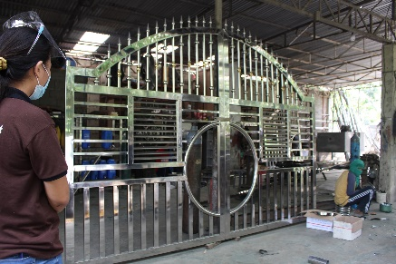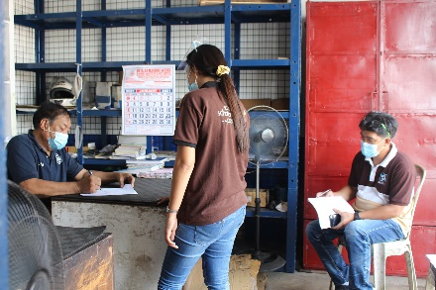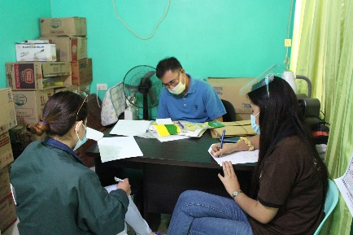

* On-going preparation of project proposals and coordination to validated firms for submission of documentary requirements

1. **CEST PROGRAM**

* Coordinated to the provincial government for confirmation of proposed selected two CEST areas

1. **iSTART Program**

* Coordinated with 6 LGUS for submission of their development plan
* Coordinated with food provider for the conduct of FGD in Sual, Malasiqui and San Fabian

1. **S&T PROMOTIONAL ACTIVITIES CONDUCTED (FOSTER STI CULTURE)**

* FB Posting: DOST PSTC-Pangasinan conducted a Technology Needs Assessment (TNA) to three (3) firms in Pangasinan (300 reached, 8 likes, 1 share)
* FB Posting: DOST PSTC-Pangasinan awards 205 liters of Carrageenan Plant Growth Promoter (PGP) to LGU-Malasiqui. (359 reached, 10 likes, 1 share)
* FB Posting: 2-day Mass Calibration of Weighing Scales for Alaminos City's 39 barangays.(230 reached, 10 likes)

1. **Food Innovation Center**

* Coordinated with FIC staff regarding the comments/recommendation of R&D unit on the submitted R&D proposal for funding
* Submitted calamay/tupig sample products to RSTL for analysis

1. **CALIBRATION SERVICES**

* Provided calibration services to the following LGUs in prepration for the conduct of their 2021 Operation Timbang Plus

LGU-Alaminos (Jan 27-28) - on-site : 112 units calibrated

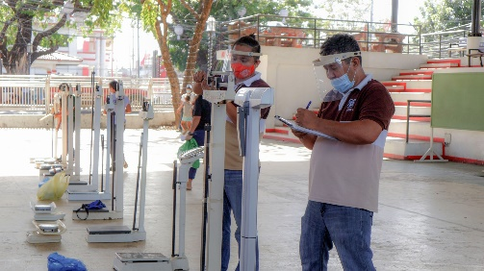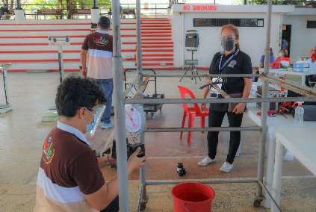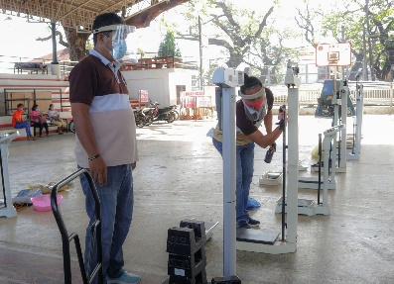

LGU-Burgos (Jan 18) – 20 units calibrated

1. **AMERIAL PROJECT**

* Assisted MIRDC AMERIAL team in the conduct of on-site visit to the following firms (Jan 27-28)

BillyMar Machine Shop - Calasiao

Aces Commercial – Calasiao

Bhog’s Tailoring – Calasiao

GM Machine Shop – Calasiao

RGL Machine Shop – San Carlos City

Mayfair Bakeshop – San Carlos City

Sancagulis MPC – Bayambang

Shelflex Candles – Bayambang

ME Enterprises – Calasiao

Nutridense Food Manufacturing Corp. – Sta. Barbara

Planas Bakeshop – Sual

Gentrics Electrical Supply - Alaminos City

JM Salt Manufacturing – Infanta

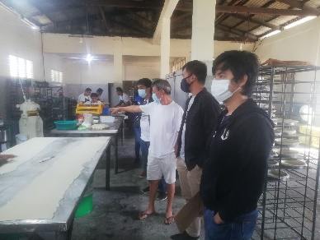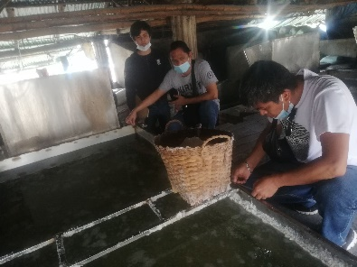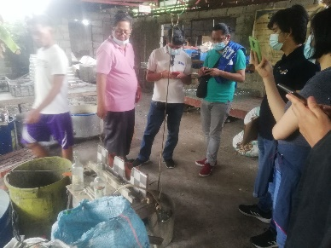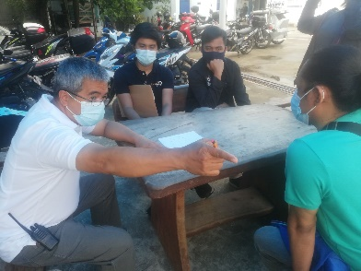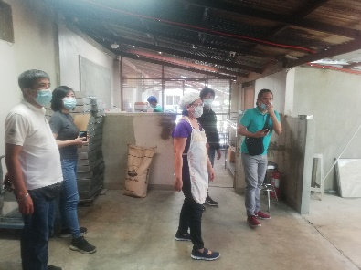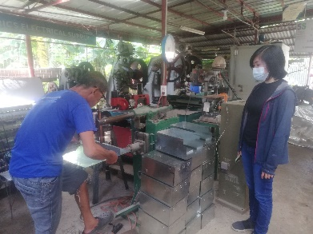

1. **TECHNOLOGY ROLL-OUT**

* Awarded 205 liters of Caraggeenan PGP to LGU-Malasiqui for distribution to their farmers (Jan 14)

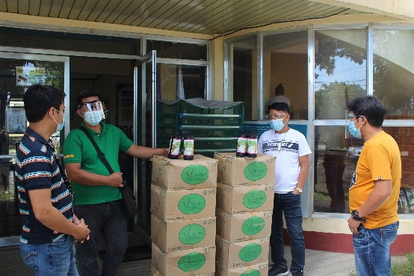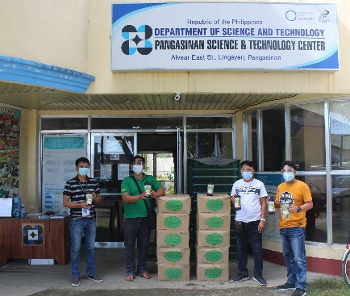

1. **MEETINGS ATTENDED**

* Meeting with 6th district Representative Hon. Tyrone Agabas (Jan 19)

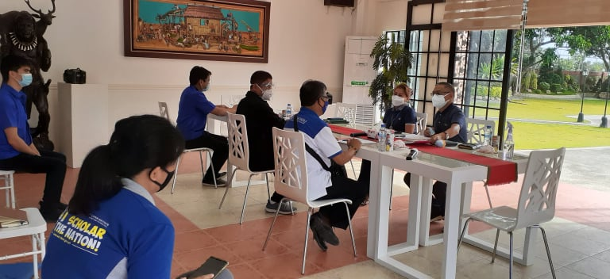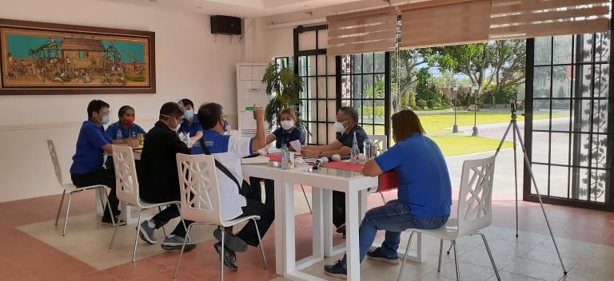

* Meeting with 4th district representative Hon. Christopher De Venecia (Jan 30)

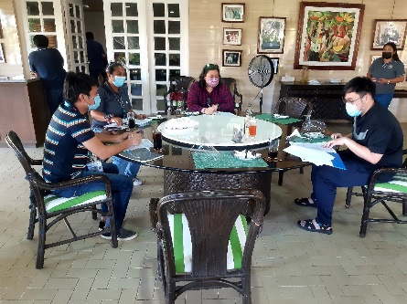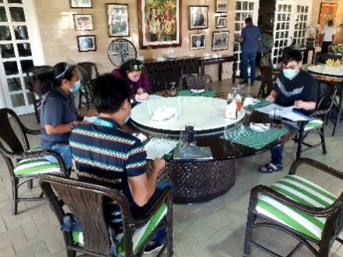

* **OFFICE MAINTENANCE**
* Secured and maintained the cleanliness of the office and its premises



**ARNOLD C. SANTOS**

PSTD